**Request for Proposal (RFP) for Administration Professional Services - Cover Letter**

Re: American Rescue Plan Act (ARP Act)

Dear Service Providers:

Attached is a copy of the City of Simonton Request for Proposals (“RFP”) for *professional administration services.* These services are being solicited to assist the City in project selection and administration of program(s) funded by the American Rescue Plan (ARP) Act. The City of Simonton is expecting a total of $219,042.00 from the U.S. Treasury as allocated in the American Rescue Plan Act, Title IX: Subtitle M: Sec 603 and is considering allocating a portion of the funds toward local infrastructure needs. Program Administration services for those infrastructure projects and other eligible ARP funded programs will remain within this scope of this procurement. If infrastructure projects are deemed feasible, engineering services will be solicited separately in a future Request for Qualifications (RFQ).

This RFP also covers the provision of professional administration services for programs that may be funded with ARP funds distributed by the State. The selected Service Provider *will* assist the City in the required administrative responsibilities, which might include project selection, as well as compliance, reporting, and close-out.

Service providers may submit proposals for any or all activities listed in the attached Scope of Work. Multiple contracts may be awarded as a result of this solicitation. The City will, in its sole discretion, determine the number of contracts awarded, and may decide not to award any contracts.

The submission requirements for your proposal are included in the attached RFP. Please submit a proposal of services and statement of qualifications to:

*City of Simonton, Erica Molina, City Secretary*

*PO Box 7 Simonton, Texas 77476*

*Email address:emolina@simontontexas.gov_*

The deadline for submission of proposals is August 12, 2022, by 12:00pm. It is the responsibility of the submitting entity to ensure that the proposal is received in a timely manner. Proposals received after the deadline will not be considered for award, regardless of whether or not the delay was outside the control of the submitting provider. City of Simonton reserves the right to negotiate with any and all service providers submitting timely proposals.

The City of Simonton is an Affirmative Action/Equal Opportunity Employer. Section 3 Residents, Minority Business Enterprises, Small Business Enterprises, Women Business Enterprises, Labor Surplus Area firms and any other applicable disadvantaged businesses including HUBs are encouraged to submit proposals.

Sincerely,

___________________________

*Jennifer Jones Ward, City Manger*

**RFP for Administration Professional Services**

City of Simonton is seeking a well-qualified administration/activity management and delivery service provider(s) (Provider) to assist the City in the overall administration or implementation of the proposed ARP Act program(s). The following outlines the RFP:

1. Project Description

***Administration Services***

A detailed Scope of Work (“SOW”) for ARP Act administration services is provided in this packet. Please refer to the United States Department of the Treasury (USDT) website for the FAQs and Fact Sheet at: https://home.treasury.gov/system/files/136/SLFRP-Fact-Sheet-FINAL1-508A.pdf and https://home.treasury.gov/system/files/136/SLFRPFAQ.pdf

for additional information regarding the ARP Act. The administration service provider to be hired will provide project selection and contract-related management services, including but not limited to the following areas:

Project Selection

Provider will assist in developing project scope(s) and complete the required ARP Act documentation. The Provider will work with the local government and Engineer, if applicable, to evaluate potential projects that provide desired benefits and are compliant with any eligibility criteria as established by the US Treasury Department.

As currently defined by US Treasury guidance, selected Projects must use the allocated funds in one of the following ways:

1. to respond to the public health emergency with respect to the Coronavirus Disease 2019 (COVID–19) or its negative economic impacts, including assistance to households, small businesses, and nonprofits, or aid to impacted industries such as tourism, travel, and hospitality;
2. to respond to workers performing essential work during the COVID–19 public health emergency by providing premium pay to eligible workers of the metropolitan city, non-entitlement unit of local government, or county that are performing such essential work, or by providing grants to eligible employers that have eligible workers who perform essential work;
3. for the provision of government services to the extent of the reduction in revenue of such metropolitan city, non-entitlement unit of local government, or county due to the COVID–19 public health emergency relative to revenues collected in the most recent full fiscal year of the metropolitan city, non-entitlement unit of local government, or county prior to the emergency; or
4. to make necessary investments in water, sewer, or broadband infrastructure.

Implementation Services

Provider will administer and provide activity delivery of infrastructure and other eligible projects approved for ARP Act funding. The selected service provider must follow all compliance and regulatory requirements of the ARP Act program(s), including 2 CFR §200.101. A description of the tasks to be performed are included in the Scope of Work below.

1. Statement of Qualifications

The City is seeking qualified professional administration service providers experienced in programadministration/activity delivery. Please provide the following as it relates to your qualifications:

**Experience of the Firm:**

* Provide introductory statement for the firm, including:
  + Form of business (corporation, limited partnership, or limited liability company, indicate the state of formation and current standing with the Secretary of State)
  + Name of contact person (single point of contact with Respondent)
  + List of criminal charges, civil lawsuits, or dispute resolutions to which Respondent is a part in the past five (5) years and the nature of the issue. Indicated if and how it was resolved
* A brief history of the service provider and any teaming partners/subcontractors, including general background, knowledge of and experience working with Federal agencies and programs
* Related recent experience in securing and managing federally-funded local projects, both infrastructure construction and service projects

**Prior Work Performance References:**

* A description of work performance and experience with the U.S. Treasury, CARES Act, CDBG, CDBG Disaster Recovery, FEMA Hazard Mitigation or similar construction and service projects
* Provide at least three project references including contact information (entity, name, title, email, and phone) from local government clients (must be within the last 3 years)
* Provide information describing the relevancy of the referenced projects for both similar construction and service projects for the references provided above as well as other pertinent projects

**Capacity to Perform:**

* Provide description of your understanding of the project scope
* Describe which specific parts of the Scope of Work the service provider proposes to perform
* Provide an organizational chart describing management and staffing for this program, including names, roles, and level of commitment
* Staff should include, but are not limited to: Project Principal, Program Manager, Project/Grant Manager, Subject Matter Expert(s), and others you determine necessary to complete the scope of work
* Describe the capacity to perform the chosen Scope of Work activities and provide resumes of all employees who may be assigned to provide services if your firm is selected
* On each resume identify the firm employing each staff member and identify any conditional/proposed hires
* Describe your current and projected workloads
* Provide description of your proposed approach/strategy to provide and perform the requested services
* A statement substantiating the resources of the service provider and the ability to carry out the scope of work requested within the proposed timeline
* Provide current fiscal year-end and year-to-date financial statements including profit and loss

1. Proposed Cost of Services

Provide your cost proposal to accomplish the Scope of Work by activity or to accomplish the entire Scope of Work as outlined below. This cost proposal shall reflect all services provided to manage programs and/or provide services for the four eligible activities under Subtitle M Sec 603(c)(1) of the ARP Act (Direct Allocation). Regarding potential funding from the ARP Act other than the Direct Allocation, the City/County will negotiate scope and pricing with the awarded vendor as those initiatives are identified.

The local government will consider dividing total requirements, when economically feasible, into smaller tasks or quantities to permit maximum participation by small and minority businesses, and women’s business enterprises. As such, Proposers may specify any maximum limit to the total dollar value of program funds they are able and willing to manage. Service providers may submit proposals for any or all activities. Preference will be given to firm fixed pricing. The proposal must include all costs that are necessary to successfully complete these activities. The lowest/best price proposal will not be used as the sole basis for entering into this contract; rather, an award will be made to the service provider(s) providing the best value, cost and other factors considered. **The local government reserves the right to negotiate pricing**.

*Upon the award of this contract, profit (either percent/actual cost) must be identified and negotiated as a separate element of the price for any contract in excess of $50,000.00*.

1. Evaluation Criteria - The proposal received will be evaluated and ranked according to the following criteria and using the rating sheet enclosed:

|  |  |  |
| --- | --- | --- |
| **Criteria** |  | **Maximum Points** |
| Experience of the Firm |  | 30 |
| Prior Work Performance |  | 20 |
| Capacity to Perform |  | 30 |
| Proposed Cost |  | 20 |
| **Total** |  | 100 |

1. Submission Requirements

* A copy of your current **certificate of insurance** for professional liability.
* **Statement of Conflicts of Interest** (if any) the service provider or key employees may have regarding these services, and a plan for mitigating the conflict(s). Note that City/County may in its sole discretion determine whether or not a conflict disqualifies a firm, and/or whether or not a conflict mitigation plan is acceptable.
* **System for Award Management**. Service Providers should have a current registration in the System for Award Management (https://www.sam.gov/SAM/). Service provider and its Principals may not be debarred or suspended nor otherwise on the Excluded Parties List System (EPLS) in the System for Award Management (SAM). Include verification that the service provider as well as its principals are not listed (are not debarred) through the System for Award Management (www.SAM.gov). Enclose a printout of the search results that includes the record date. This clearance information should be included in the service provider’s Proposal. The clearance in the Service Provider’s proposal must be re-verified prior to award. Federal awarding agencies may relax the timing of the requirement for active SAM registration at time of allocation in order to expeditiously issue funding. At the time of award, the requirements of 2 CFR § 200.206, Federal awarding agency review of risk posed by recipients, continue to apply. Current registrants in SAM with active registrations expiring between April 1, 2021 and September 30, 2021 will automatically be afforded a one-time extension of 180 days. (2 CFR § 25.110).
* **Form CIQ,** (enclosed). Texas Local Government Code chapter 176 requires that any vendor or person who enters or seeks to enter into a contract with a local government entity disclose in the Questionnaire Form CIQ the vendor or person’s employment, affiliation, business relationship, family relationship or provision of gifts that might cause a conflict of interest with a local government entity. Questionnaire form CIQ is included in the RFP and must be submitted with the response. **Certification Regarding Lobbying (**enclosed). Certification for Contracts, Grants, Loans, and Cooperative Agreements is included in the RFP and must be submitted with the response.
* **Form 1295,** (enclosed). Effective January 1,2018, all contracts and contract amendments, extensions, or renewals executed by the Commissioners Court will require the completion of Form 1295 “Certificate of Interested Parties” pursuant to Government Code § 2252.908. Form 1295 must be completed by the awarded vendor at time of signed contract submission. Form 1295 is included in this RFP for your information. Form 1295 requires the inclusion of an “unsworn declaration” which includes, among other things, the date of birth and address of the authorized representative signing the form.
* **Required Contract Provisions**. Applicable provisions (enclosed) must be included in all contracts executed as a result of this RFP.

1. Contracting with HUB, small and minority businesses, women's business enterprises, and labor surplus area firms.

If the awarded vendor (prime) uses subcontractors, it must take all necessary affirmative steps to assure that small and minority businesses, women's business enterprises, and labor surplus area firms are used. The following affirmative steps are required of the prime contractor:

1. Placing qualified small and minority businesses and women's business enterprises on solicitation lists;
2. Assuring that small and minority businesses, and women's business enterprises are solicited whenever they are potential sources;
3. Dividing total requirements, when economically feasible, into smaller tasks or quantities to permit maximum participation by small and minority businesses, and women's business enterprises;
4. Establishing delivery schedules, where the requirement permits, which encourage participation by small and minority businesses, and women's business enterprises;
5. Using the services and assistance, as appropriate, of such organizations as the Small Business Administration (SBA) and the Minority Business Development Agency (MBDA) of the Department of Commerce.
6. The Prime Vendor should utilize the MBDA Center that is in the closest proximity to locality. Email your RFP to the appropriate center.

Minority-owned businesses may be eligible for contract procurement assistance with public and private sector entities from MBDA centers:

|  |  |
| --- | --- |
| Dallas MBDA Business Center | Houston MBDA Business Center |
| 8828 N. Stemmons Freeway, Ste. 550B | 3100 Main Street, Ste. 701 |
| Dallas, TX 75247 | Houston, TX 77002 |
| 214-920-2436 | 713-718-8974 |
| Website: https://www.mbdadfw.com  Email: admin1@mbdadallas.com | Website: https://www.mbda.gov/business-center/houston-mbda-business-center |
|  | Email: MBDA@hccs.edu |
|  |  |
| El Paso MBDA Business Center | San Antonio MBDA Business Center |
| 2401 East Missouri Avenue | 501 W. Cesar E. Chavez Blvd., Ste. 3.324B |
| El Paso, TX 79903 | San Antonio, TX 78207 |
| 915-351-6232 | 210-458-2480 |
| Website: https://www.mbda.gov/business-center/el-paso-mbda-business-center | Website: https://www.mbda.gov/business-center/san-antonio-mbda-business-center |
| Email: treed@ephcc.org | Email: orestes.hubbard@utsa.edu |

Small and woman-owned businesses may be eligible for assistance from SBA Women’s Business Centers:

|  |  |
| --- | --- |
| Dallas Fort Worth WBC | WBEA – Women’s Business Center |
| 7800 N. Stemmons Fwy., Ste. 120 | 9800 Northwest Freeway, Ste. 120 |
| Dallas, TX 75247 | Houston, TX 77092 |
| 214-572-9452 | 713-681-9232 |
| Website: https://womensbusinesscenterdfw.com/ | Website: https://www.wbea-texas.org/womens-business-center |
| Email: wbcdfw@liftfund.com | Email: wbc@wbea-texas.org |
|  |  |
| LiftFund Women’s Business Center |  |
| 600 Soledad St. |  |
| San Antonio, TX 78205 |  |
| 888-215-2373 ext. 3000 |  |
| Website: https://womensbusinesscentersa.com/ |  |
| Email: wbc@liftfund.com |  |

SBA also provides assistance at Small Business Development Centers located across Texas:

***https://americassbdc.org/small-business-consulting-and-training/find-your-sbdc/***

1. Deadline for Submission – Proposals must be received no later than *August 12, 2022, by 12:00pm*. It is the responsibility of the submitting entity to ensure that the proposal is received in a timely manner. Proposals received after the deadline will not be considered for award, regardless of whether or not the delay was outside the control of the submitting firm. Please submit your proposal in .pdf format via a thumb drive and 3 hard copies to:

City of Simonton

35011 FM 1093 Simonton, Texas 77476

Any questions or requests for clarification must be submitted in writing via EMAIL to the address above at least 3 business days prior to the deadline. City of Simonton may, if appropriate, circulate the question and answer to all service providers submitted proposals.

Required RFP Forms as provided in the RFP must be submitted, or the proposal shall be considered non-responsive.

**SCOPE OF WORK**

**Administration Services**

The Contractor shall provide the following scope of services:

**SCOPE OF SERVICES REQUESTED**

Providers will help the City fulfill State and Federal ARP Act statutory responsibilities related to recovery from COVID-19. Providers will assist the City in completion of ARP Act program(s). Respondents may be qualified to provide Program Administration services for one or more programs or services (environmental, acquisition, general administration, etc.) Program administrative services must be performed in compliance with the guidance provided by the US Treasury.

**DESCRIPTION OF SERVICES AND SPECIAL CONDITIONS**

Respondents must be able to perform the tasks listed herein to be considered eligible for an award under this Solicitation. Respondents should provide a detailed narrative of their experience as it relates to each of the items below. Respondents should clearly indicate if they intend to provide services in-house with existing staff or through subcontracting or partnership arrangements. Program Administration Services will be provided in conformance with the guidance documents utilizing forms provided by the US Treasury or other designated agencies, if applicable. The Providers shall furnish pre-funding and post-funding program administrative services to complete the ARP Act projects, including, but not limited to the following:

**Program Administration Services**

1. General Administrative Duties:
   1. Monitor program compliance including all ARP Act requirements.
   2. Assist in establishing and maintaining financial processes.
   3. Obtain and maintain copies of the most current program agreement, if such exists, including all related change requests, revisions and attachments.
   4. Establish and maintain record keeping systems.
   5. Implementation and coordination of Affirmatively Furthering Fair Housing (“AFFH”) requirements (if required).
   6. Implementation and coordination of Section 504 requirements (if required)
   7. Assist with resolving monitoring and audit findings.
   8. Serve as monitoring liaison.
   9. Assist with resolving third party claims.
   10. Report suspected fraud.
   11. Submit timely responses to requests for additional information.
   12. Assist with the system of record, documentation, reports, change requests, progress of projects, etc.
   13. Coordinate, as necessary, between recipient and any other appropriate service providers (i.e. Engineer, Environmental, etc.), contractor, subcontractor and other state/federal agencies to effectuate the services requested.
   14. May assist in public hearings, if required
   15. Provide project status updates
2. Procurement
   1. Assist with procurements as necessary for program implementation
   2. Monitor compliance with procurement regulations and policies per 2 CFR 200
3. Financial Duties:
   * 1. Prepare required reports for submission.
     2. Provide guidance in establishing a bank account for program funds.
     3. Provide guidance on Program compliance.
     4. Assist with developing fraud prevention and abuse practices
     5. Prepare for submission closeout documents
     6. Assist in preparation of contract revisions and supporting documents including but not limited to:
        + Amendments/modifications

xi. Assist with other administrative duties required to deliver the project

1. Projects with Beneficiaries including Households, Non-profits, Businesses, and Industries:
   1. Identify the need for this program.
   2. Project planning, design, and startup
      * + Assist recipient with procuring necessary vendors as needed.
   3. Intake meetings
      * + Advertise, schedule, and conduct intake with interested potential beneficiaries.  During intake meetings case managers will collect all available documentation necessary to determine eligibility.
   4. Eligibility verification
      * + Management staff will review all intake documentation and verify eligibility.
        + If applicable, verify duplicative benefits (DOB) and calculate eligible receipts.
        + Maintain recipient data in a secure system and comply with all record-keeping requirements.
   5. Assistance package generation and approval
   6. Review change requests and all required documentation related to any change requests.
   7. Final Documentation of recipients
      * + File, audit, and closeout
        + Complete final audit to ensure all procedures were properly followed.
2. Premium Pay to Eligible Workers and Eligible Employers
   1. Identify the need for this program
   2. Project planning, design, and startup
   3. Advertise, schedule, and conduct intake with interested potential eligible employers.
      * + During intake meetings case managers will collect all available documentation necessary to determine eligibility.
   4. Eligibility verification
      * + Management staff will review all intake documentation and verify eligibility.
        + If applicable, verify duplicative benefits (DOB).
        + Maintain recipient data in a secure system and comply with all record-keeping requirements.
   5. Assistance package generation and approval
   6. Review change requests and all required documentation related to any change requests.
   7. Final Documentation of recipients
      * + File, audit, and closeout
        + Complete final audit to ensure all procedures were properly followed.
3. Reconciliation of Revenue Reductions
   1. Identify the need for this program
   2. Project planning, design, and startup
   3. Calculate revenue loss in accordance with Department of Treasury guidance
   4. Review change requests and all required documentation related to any change requests
   5. Final Documentation of recipients
      * + File, audit, and closeout
        + Complete final audit to ensure all procedures were properly followed
4. Necessary Water, Sewer, or Broadband Infrastructure
   1. Identify the need for this program
   2. Project planning, design, and startup
      * + Assist the recipient in submitting/setting up project(s)
   3. Assist with developing contract/bid packages that meet ARP program requirements
   4. Assist with monitoring and reporting contractor's performance
   5. Receive, review, recommend, and process any change orders as appropriate to the individual projects
   6. Assist the recipient with vendor Draws/Close Out
   7. Compile and review for completeness contract/closeout packages that meet ARP program requirements
   8. Labor Standards duties (as required):
      * + Provide all Labor Standards Officer (LSO) Services.
        + Monitor compliance with all relevant labor standards regulations.
        + Maintain document files to support compliance.
   9. Environmental Services
      * + Review each project description to ascertain and/or verify the level of environmental review requirements.
        + Prepare, complete and submit required forms for environmental review and provide all documentation to support environmental findings;
        + Consult and coordinate with oversight/regulatory agencies to facilitate environmental clearance;
        + Reporting
   10. Acquisition Duties:
       * + Submit acquisition reports and related documents.
         + Establish acquisition files (if necessary).
         + Complete acquisition activities (if necessary).

**COST OF SERVICES**

The Responder should enter pricing which includes all costs, expense, and materials needed to perform the services in accordance with this RFP. Pricing for ARP funded projects other than Subtitle M Sec 603 projects will be determined with the awarded vendor once projects are identified.

LUMP SUM PRICE: $_____________________________

If your pricing is only for a specific activity(ies) in this scope, please indicate the service(s) with your pricing. Respondents proposing to offer specific services are limited to environmental services and will be scored only on that service.

SPECIFIC SERVICE DESCRIPTION: __________________________________________________________________________________.

PRICE: $__________________________

**Administration Professional Services Rating Sheet**

**ARP Act**

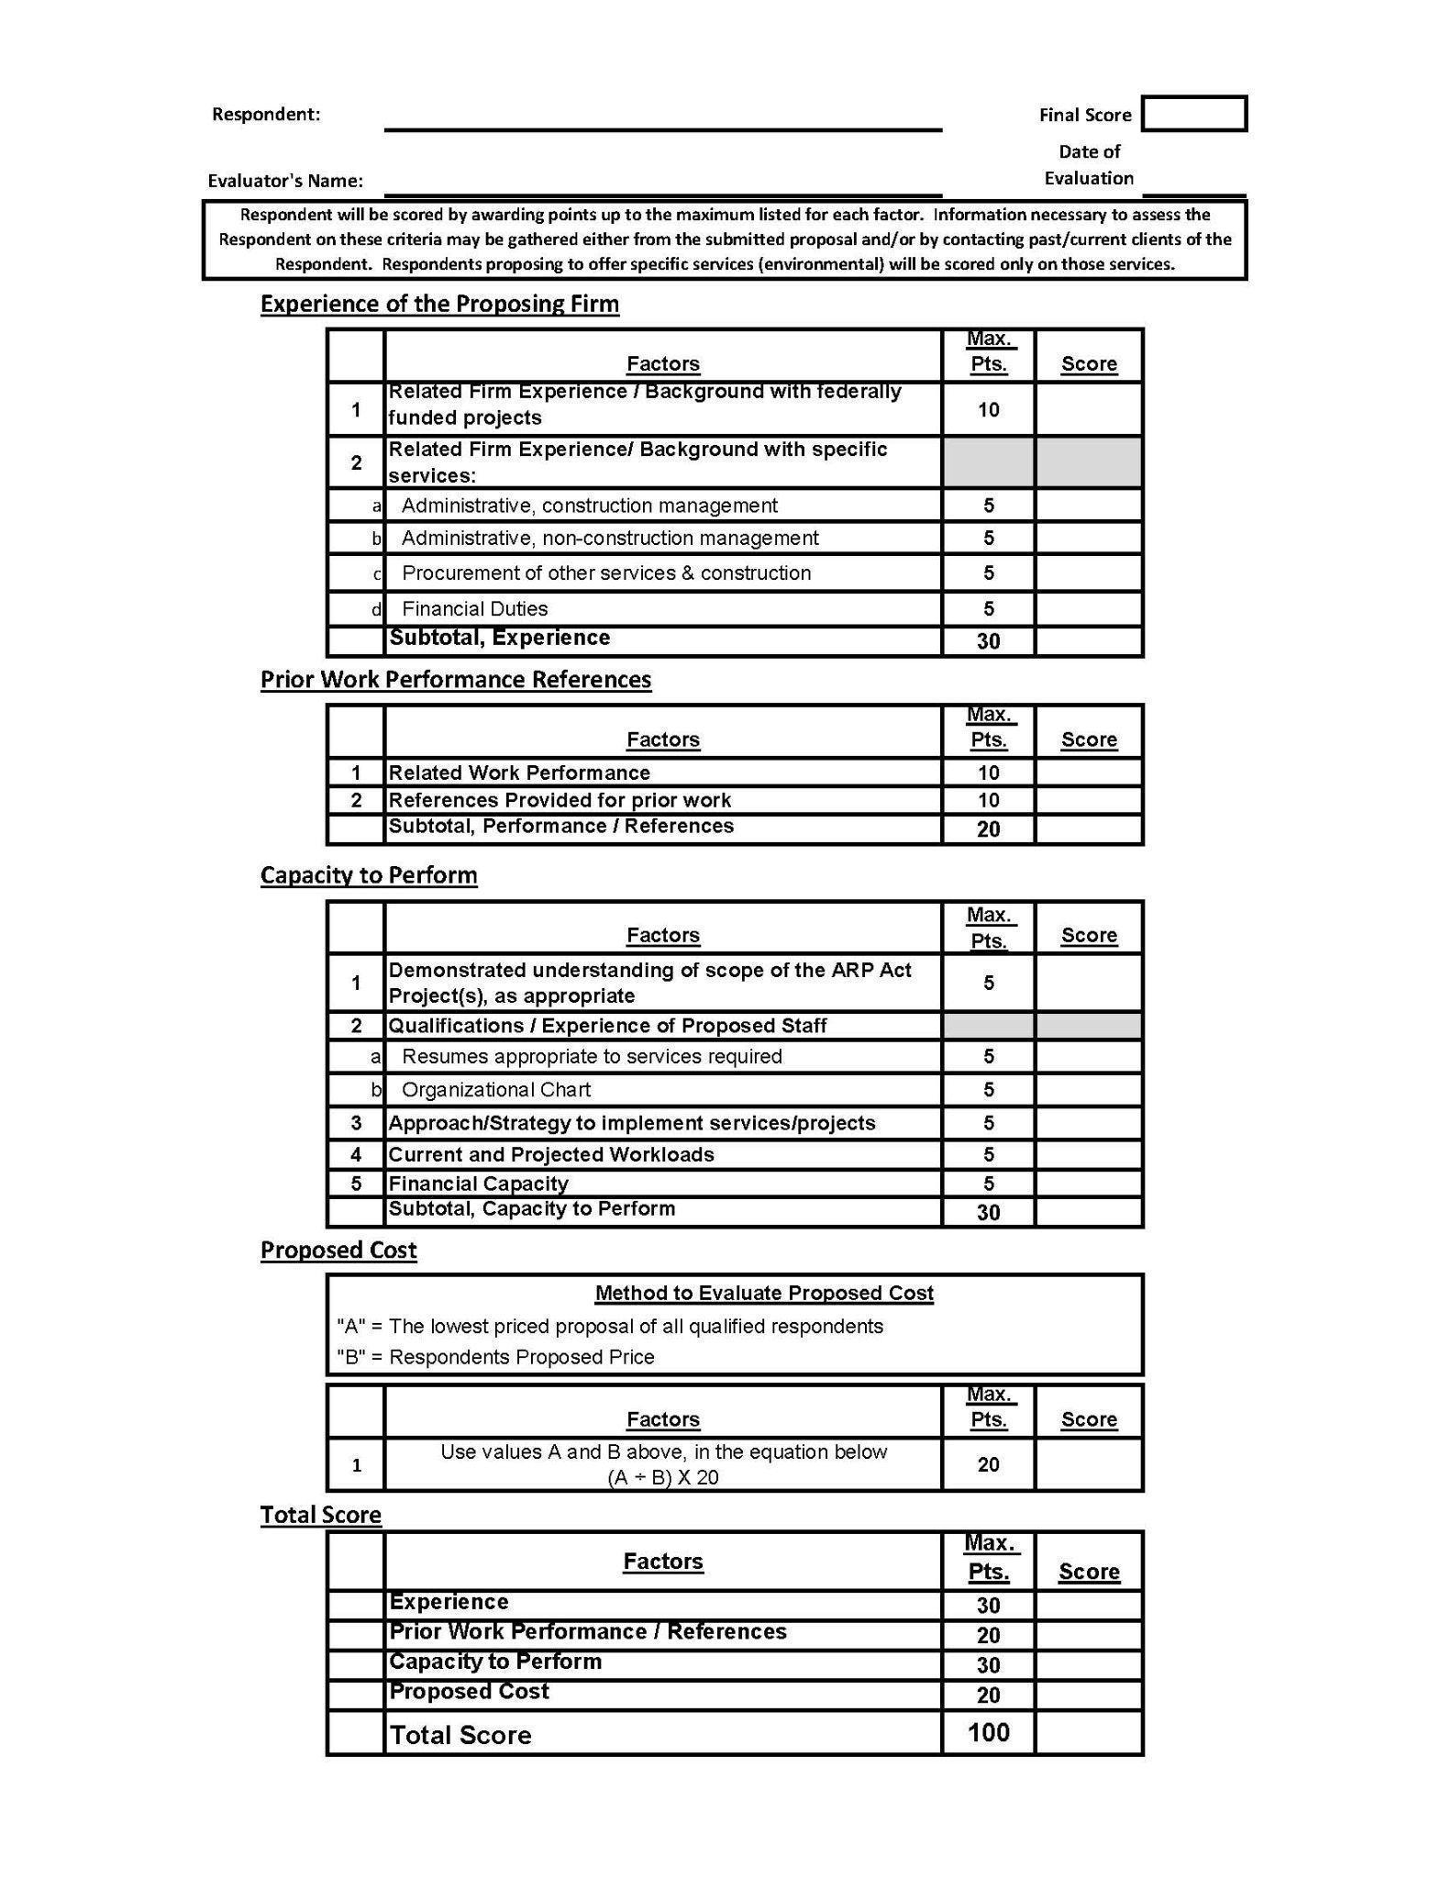

**Insert Certificate of Insurance**

**Insert System for Award Management (SAM) record search for company name and company principal**

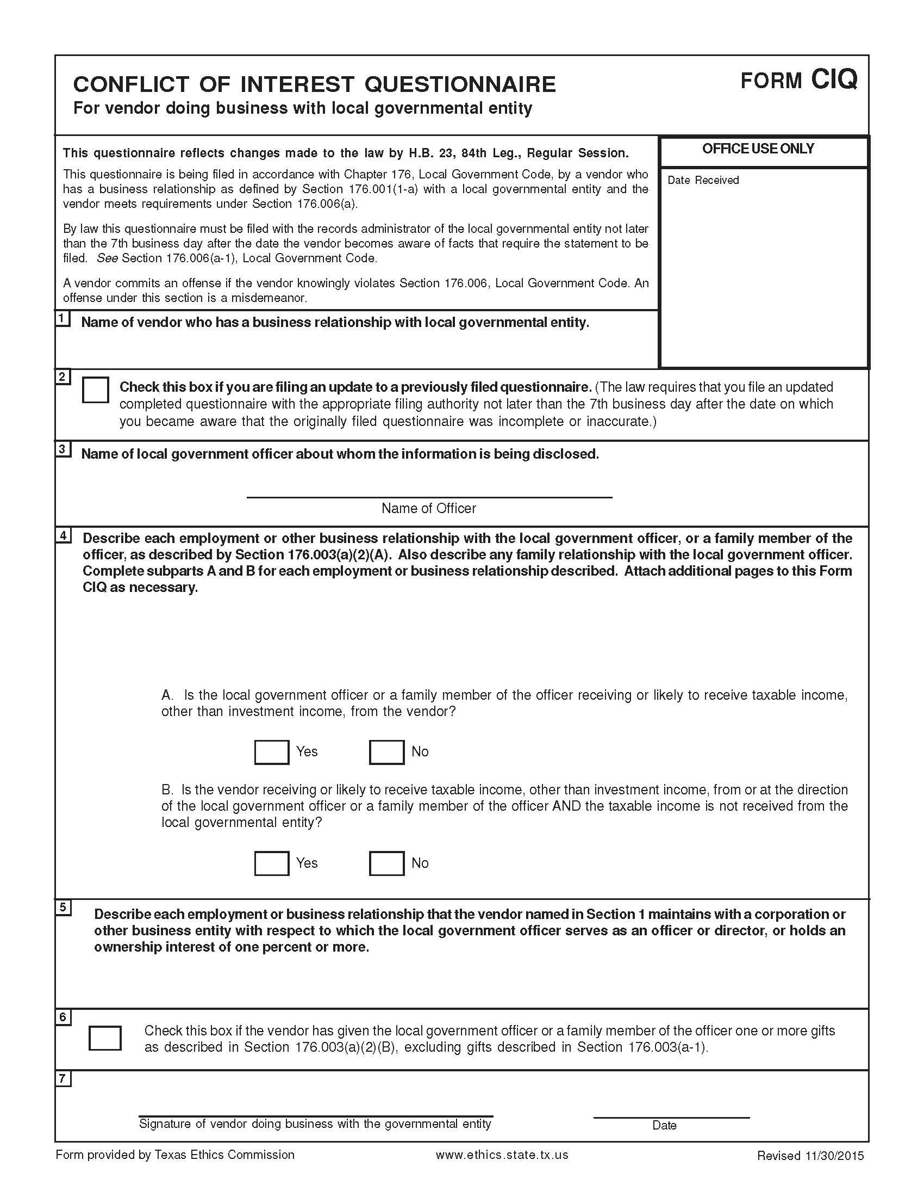

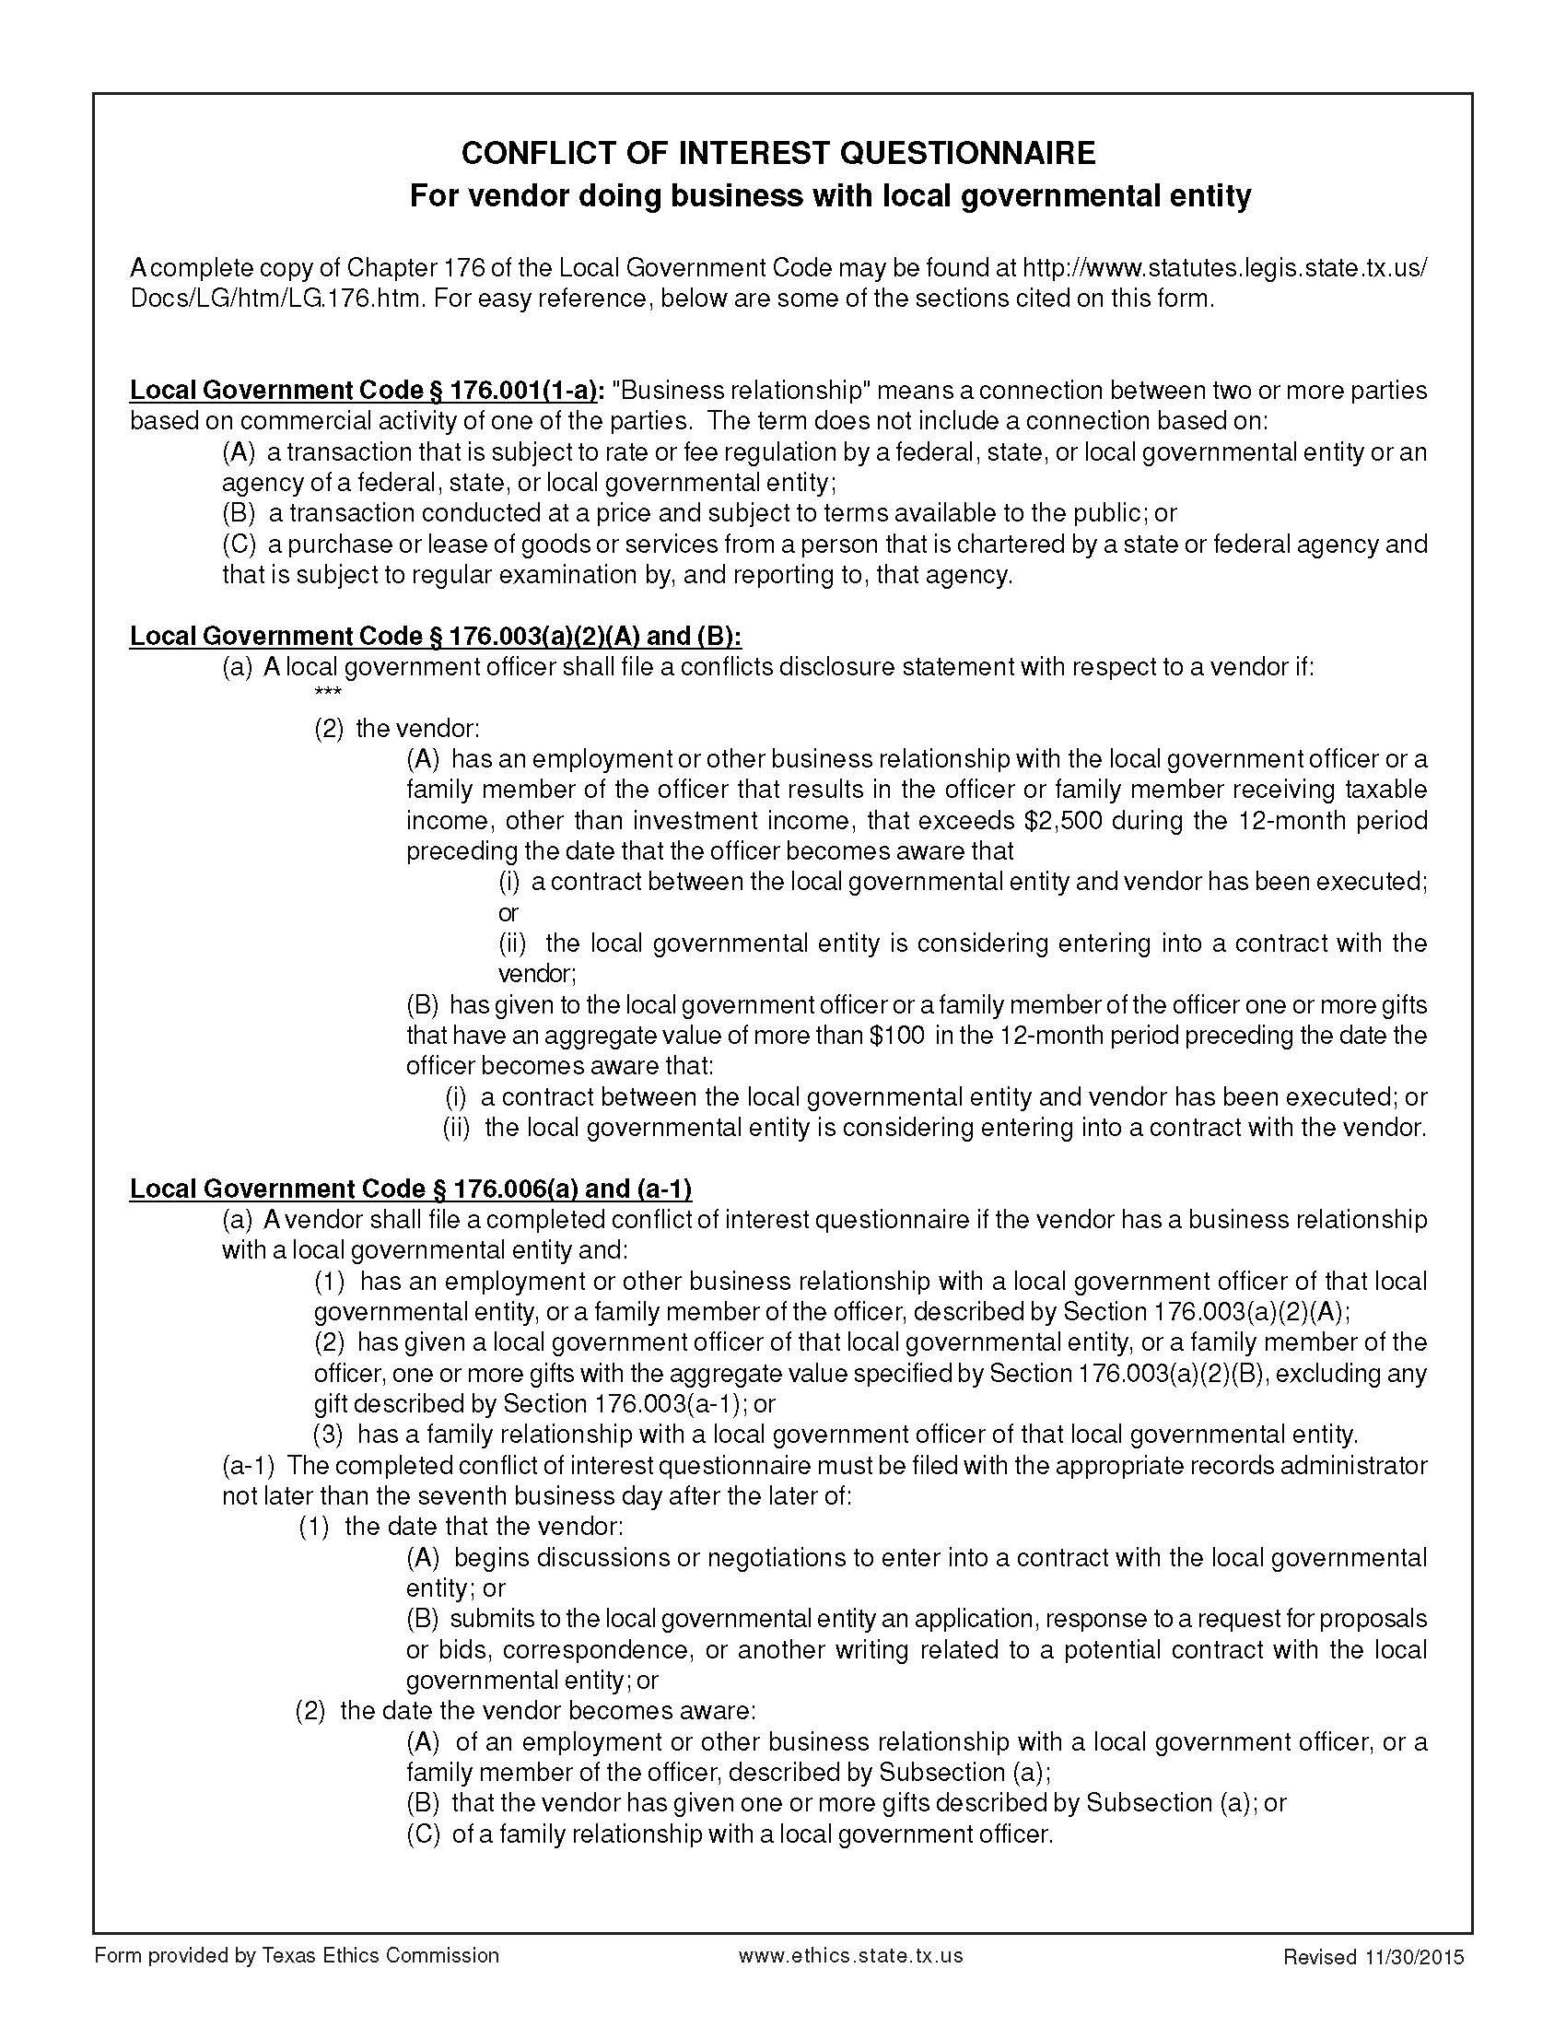

Certification Regarding Lobbying

(To be submitted with each bid or offer exceeding $100,000)

The undersigned certifies, to the best of his or her knowledge and belief, that:

(a) No Federal appropriated funds have been paid or will be paid, by or on behalf of the undersigned, to any person for influencing or attempting to influence an officer or employee of an agency, a Member of Congress, an officer or employee of Congress, or an employee of a Member of Congress in connection with the awarding of any Federal contract, the making of any Federal grant, the making of any Federal loan, the entering into of any cooperative agreement, and the extension, continuation, renewal, amendment, or modification of any Federal contract, grant, loan, or cooperative agreement.

(b) If any funds other than Federal appropriated funds have been paid or will be paid to any person for influencing or attempting to influence an officer or employee of any agency, a Member of Congress, an officer or employee of Congress, or an employee of a Member of Congress in connection with this Federal contract, grant, loan, or cooperative agreement, the undersigned shall complete and submit Standard Form-LLL, “Disclosure Form to Report Lobbying,” in accordance with its instructions.

(c) The undersigned shall require that the language paragraph 1 and 2 of this anti-lobbying certification be included in the award documents for all subawards at all tiers (including subcontracts, subgrants, and contracts under grants, loans, and cooperative agreements) and that all recipients shall certify and disclose accordingly.

This certification is a material representation of fact upon which reliance was placed when this transaction was made or entered into. Submission of this certification is a prerequisite for making or entering into this transaction imposed by 31, U.S.C. § 1352 (as amended by the Lobbying Disclosure Act of 1995).

The Contractor, ___________________, certifies or affirms the truthfulness and accuracy of each statement of its certification and disclosure, if any. In addition, the Contractor understands and agrees that the provisions of 31 U.S.C. § 3801 et seq., apply to this certification and disclosure, if any.

_____________________________________

Signature of Contractor’s Authorized Official

________________________________________________

Printed Name and Title of Contractor’s Authorized Official

_____________________________________

Date

**INSTRUCTIONS FOR COMPLETION OF SF-LLL, DISCLOSURE OF LOBBYING ACTIVITIES**

This disclosure form shall be completed by the reporting entity, whether subawardee or prime Federal recipient, at the initiation or receipt of a covered Federal action, or a material change to a previous filing, pursuant to title 31 U.S.C. section 1352. The filing of a form is required for each payment or agreement to make payment to any lobbying entity for influencing or attempting to influence an officer or employee of any agency, a Member of Congress, an officer or employee of Congress, or an employee of a Member of Congress in connection with a covered Federal action. Complete all items that apply for both the initial filing and material change report. Refer to the implementing guidance published by the Office of Management and Budget for additional information.

1. Identify the type of covered Federal action for which lobbying activity is and/or has been secured to influence the outcome of a covered Federal action.

2. Identify the status of the covered Federal action.

3. Identify the appropriate classification of this report. If this is a follow-up report caused by a material change to the information previously reported, enter the year and quarter in which the change occurred. Enter the date of the last previously submitted report by this reporting entity for this covered Federal action.

4. Enter the full name, address, city, State and zip code of the reporting entity. Include Congressional District, if known. Check the appropriate classification of the reporting entity that designates if it is, or expects to be, a prime or subaward recipient. Identify the tier of the subawardee, e.g., the first subawardee of the prime is the 1st tier. Subawards include but are not limited to subcontracts, subgrants and contract awards under grants.

5. If the organization filing the report in item 4 checks “Subawardee,” then enter the full name, address, city, State and zip code of the prime Federal recipient. Include Congressional District, if known.

6. Enter the name of the federal agency making the award or loan commitment. Include at least one organizational level below the agency name, if known. For example, the Department of Transportation, United States Coast Guard.

7. Enter the Federal program name or description for the covered Federal action (item 1). If known, enter the full Catalog of Federal Domestic Assistance (CFDA) number for grants, cooperative agreements, loans, and loan commitments.

8. Enter the most appropriate Federal identifying number available for the Federal action identified in item 1 (e.g., Request for Proposal (RFP) number; Invitations for Bid (IFB) number; grant announcement number; the contract, grant, or loan award number; the application/proposal control number assigned by the Federal agency). Included prefixes, e.g., “RFP-DE-90-001.”

9. For a covered Federal action where there has been an award or loan commitment by the Federal agency, enter the Federal amount of the award/loan commitment for the prime entity identified in item 4 or 5.

10. (a) Enter the full name, address, city, State and zip code of the lobbying registrant under the Lobbying Disclosure Act of 1995 engaged by the reporting entity identified in item 4 to influence the covered Federal action.

(b) Enter the full names of the individual(s) performing services, and include full address if different from 10(a). Enter Last Name, First Name, and Middle Initial (MI).

11. The certifying official shall sign and date the form, print his/her name, title, and telephone number.

According to the Paperwork Reduction Act, as amended, no persons are required to respond to a collection of information unless it displays a valid OMB control Number. The valid OMB control number for this information collection is OMB No. 0348-0046. Public reporting burden for this collection of information is estimated to average 10 minutes per response, including time for reviewing instructions, searching existing data sources, gathering and maintaining the data needed, and completing and reviewing the collection of information. Send comments regarding the burden estimate or any other aspect of this collection of information, including suggestions for reducing this burden, to the Office of Management and Budget, Paperwork Reduction Project (0348-0046), Washington, DC 20503

Approved by OMB

0348-0046

**Disclosure of Lobbying Activities**

Complete this form to disclose lobbying activities pursuant to 31 U.S.C. 1352

(See reverse for public burden disclosure)

|  |  |  |  |
| --- | --- | --- | --- |
| **Type of Federal Action:**  a. contract  ____ b. grant  c. cooperative agreement  d. loan  e. loan guarantee  f. loan insurance | **Status of Federal Action:**  a. bid/offer/application  _____ b. initial award  c. post-award | | **Report Type:**  a. initial filing  _____ b. material change |
| **Name and Address of Reporting Entity:**  ____ Prime _____ Subawardee  Tier______, if Known:  **Congressional District, if known:** | | **If Reporting Entity in No. 4 is Subawardee,** Enter Name and Address of Prime:  **Congressional District, if known:** | |
| **Federal Department/Agency:** | | **7. Federal Program Name/Description:**  CFDA Number, *if applicable*: __________________ | |
| **Federal Action Number,** *if known:* | | **9. Award Amount**, *if known:*  **$** | |
| **10. a. Name and Address of Lobbying Registrant**  *(if individual, last name, first name, MI):* | | **b. Individuals Performing Services** *(including address if different from No. 10a)*  *(last name, first name, MI):* | |
| **11. Information requested through this form is authorized by title 31 U.S.C. section 1352. This disclosure of lobbying activities is a material representation of fact upon which reliance was placed by the tier above when this transaction was made or entered into. This disclosure is required pursuant to 31 U.S.C. 1352. This information will be reported to the Congress semi-annually and will be available for public inspection. Any person who fails to file the required disclosure shall be subject to a civil penalty of not less than $10,000 and not more than $100,000 for each such failure.** | | **Signature: __________________________________**  **Print Name: _____**  **Title: _____**  **Telephone No.: ____________ Date: _______** | |
| **Federal Use Only** | | **Authorized for Local Reproduction**  **Standard Form - LLL (Rev. 7-97)** | |

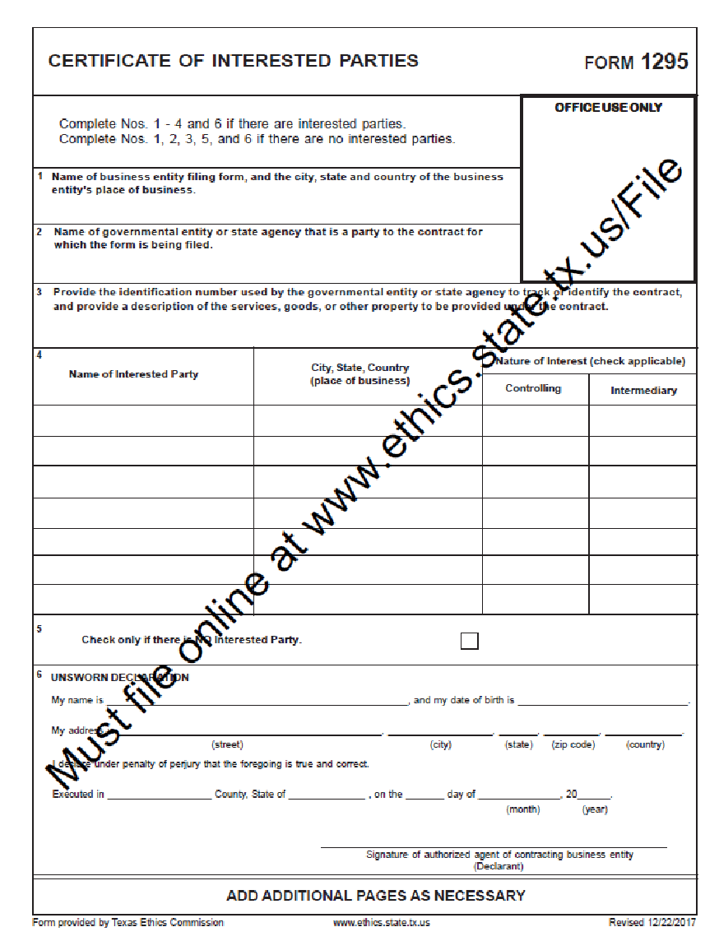

(To be completed by awarded vendor)

**CONTRACT PROVISIONS**

The non-Federal entity's contracts should contain applicable provisions described in Appendix II to Part 200—Contract Provisions for non-Federal Entity Contracts Under Federal Awards. The non-Federal entity's contracts may contain the applicable provisions described in Appendix II to Part 200—Contract Provisions for non-Federal Entity Contracts Under Federal Awards. **\*Language as of May 21, 2021.**

**All Contracts**

|  |  |  |
| --- | --- | --- |
| **THRESHOLD** | **PROVISION** | **CITATION** |
| >$250,000  (Simplified Acquisition Threshold) | Contracts for more than the simplified acquisition threshold, which is the inflation adjusted amount determined by the Civilian Agency Acquisition Council and the Defense Acquisition Regulations Council (Councils) as authorized by 41 U.S.C. 1908, must address administrative, contractual, or legal remedies in instances where contractors violate or breach contract terms, and provide for such sanctions and penalties as appropriate. | 2 CFR 200  APPENDIX II (A) |
| >$10,000 | All contracts in excess of $10,000 must address termination for cause and for convenience by the non-Federal entity including the manner by which it will be effected and the basis for settlement. | 2 CFR 200  APPENDIX II (B) |
| None | Equal Employment Opportunity. Except as otherwise provided under 41 CFR Part 60, all contracts that meet the definition of ‘‘federally assisted construction contract’’ in 41 CFR Part 60–1.3 must include the equal opportunity clause provided under 41 CFR 60–1.4(b), in accordance with Executive Order 11246, ‘‘Equal Employment Opportunity’’ (30 FR 12319, 12935, 3 CFR Part, 1964–1965 Comp., p. 339), as amended by Executive Order 11375, ‘‘Amending Executive Order 11246 Relating to Equal Employment Opportunity,’’ and implementing regulations at 41 CFR part 60, ‘‘Office of Federal Contract Compliance Programs, Equal Employment Opportunity, Department of Labor.’’  41 CFR 60-1.4 Equal opportunity clause.  (b) Federally assisted construction contracts. (1) Except as otherwise provided, each administering agency shall require the inclusion of the following language as a condition of any grant, contract, loan, insurance, or guarantee involving federally assisted construction which is not exempt from the requirements of the equal opportunity clause:  The [recipient] hereby agrees that it will incorporate or cause to be incorporated into any contract for construction work, or modification thereof, as defined in the regulations of the Secretary of Labor at 41 CFR Chapter 60, which is paid for in whole or in part with funds obtained from the Federal Government or borrowed on the credit of the Federal Government pursuant to a grant, contract, loan, insurance, or guarantee, or undertaken pursuant to any Federal program involving such grant, contract, loan, insurance, or guarantee, the following equal opportunity clause:  During the performance of this contract, the contractor agrees as follows:  (1) The contractor will not discriminate against any employee or applicant for employment because of race, color, religion, sex, sexual orientation, gender identity, or national origin. The contractor will take affirmative action to ensure that applicants are employed, and that employees are treated during employment without regard to their race, color, religion, sex, sexual orientation, gender identity, or national origin. Such action shall include, but not be limited to the following:  Employment, upgrading, demotion, or transfer; recruitment or recruitment advertising; layoff or termination; rates of pay or other forms of compensation; and selection for training, including apprenticeship. The contractor agrees to post in conspicuous places, available to employees and applicants for employment, notices to be provided setting forth the provisions of this nondiscrimination clause.  (2) The contractor will, in all solicitations or advertisements for employees placed by or on behalf of the contractor, state that all qualified applicants will receive consideration for employment without regard to race, color, religion, sex, sexual orientation, gender identity, or national origin.  (3) The contractor will not discharge or in any other manner discriminate against any employee or applicant for employment because such employee or applicant has inquired about, discussed, or disclosed the compensation of the employee or applicant or another employee or applicant. This provision shall not apply to instances in which an employee who has access to the compensation information of other employees or applicants as a part of such employee's essential job functions discloses the compensation of such other employees or applicants to individuals who do not otherwise have access to such information, unless such disclosure is in response to a formal complaint or charge, in furtherance of an investigation, proceeding, hearing, or action, including an investigation conducted by the employer, or is consistent with the contractor's legal duty to furnish information.  (4) The contractor will send to each labor union or representative of workers with which he has a collective bargaining agreement or other contract or understanding, a notice to be provided advising the said labor union or workers' representatives of the contractor's commitments under this section, and shall post copies of the notice in conspicuous places available to employees and applicants for employment.  (5) The contractor will comply with all provisions of Executive Order 11246 of September 24, 1965, and of the rules, regulations, and relevant orders of the Secretary of Labor.  (6) The contractor will furnish all information and reports required by Executive Order 11246 of September 24, 1965, and by rules, regulations, and orders of the Secretary of Labor, or pursuant thereto, and will permit access to his books, records, and accounts by the administering agency and the Secretary of Labor for purposes of investigation to ascertain compliance with such rules, regulations, and orders.  (7) In the event of the contractor's noncompliance with the nondiscrimination clauses of this contract or with any of the said rules, regulations, or orders, this contract may be canceled, terminated, or suspended in whole or in part and the contractor may be declared ineligible for further Government contracts or federally assisted construction contracts in accordance with procedures authorized in Executive Order 11246 of September 24, 1965, and such other sanctions may be imposed and remedies invoked as provided in Executive Order 11246 of September 24, 1965, or by rule, regulation, or order of the Secretary of Labor, or as otherwise provided by law.  (8) The contractor will include the portion of the sentence immediately preceding paragraph (1) and the provisions of paragraphs (1) through (8) in every subcontract or purchase order unless exempted by rules, regulations, or orders of the Secretary of Labor issued pursuant to section 204 of Executive Order 11246 of September 24, 1965, so that such provisions will be binding upon each subcontractor or vendor. The contractor will take such action with respect to any subcontract or purchase order as the administering agency may direct as a means of enforcing such provisions, including sanctions for noncompliance:  Provided, however, that in the event a contractor becomes involved in, or is threatened with, litigation with a subcontractor or vendor as a result of such direction by the administering agency, the contractor may request the United States to enter into such litigation to protect the interests of the United States.  The [recipient] further agrees that it will be bound by the above equal opportunity clause with respect to its own employment practices when it participates in federally assisted construction work: Provided, that if the [recipient] so participating is a State or local government, the above equal opportunity clause is not applicable to any agency, instrumentality or subdivision of such government which does not participate in work on or under the contract.  The [recipient] agrees that it will assist and cooperate actively with the administering agency and the Secretary of Labor in obtaining the compliance of contractors and subcontractors with the equal opportunity clause and the rules, regulations, and relevant orders of the Secretary of Labor, that it will furnish the administering agency and the Secretary of Labor such information as they may require for the supervision of such compliance, and that it will otherwise assist the administering agency in the discharge of the agency's primary responsibility for securing compliance.  The [recipient] further agrees that it will refrain from entering into any contract or contract modification subject to Executive Order 11246 of September 24, 1965, with a contractor debarred from, or who has not demonstrated eligibility for, Government contracts and federally assisted construction contracts pursuant to the Executive Order and will carry out such sanctions and penalties for violation of the equal opportunity clause as may be imposed upon contractors and subcontractors by the administering agency or the Secretary of Labor pursuant to Part II, Subpart D of the Executive Order. In addition, the [recipient] agrees that if it fails or refuses to comply with these undertakings, the administering agency may take any or all of the following actions: Cancel, terminate, or suspend in whole or in part this grant (contract, loan, insurance, guarantee); refrain from extending any further assistance to the [recipient] under the program with respect to which the failure or refund occurred until satisfactory assurance of future compliance has been received from such [recipient]; and refer the case to the Department of Justice for appropriate legal proceedings. | 2 CFR 200  APPENDIX II (C) and 41 CFR §60-1.4(b) |
| >$2,000 | Davis-Bacon Act, as amended (40 U.S.C. 3141-3148). When required by Federal program legislation, all prime construction contracts in excess of $2,000 awarded by non-Federal entities must include a provision for compliance with the Davis-Bacon Act (40 U.S.C. 3141-3144, and 3146-3148) as supplemented by Department of Labor regulations (29 CFR Part 5, “Labor Standards Provisions Applicable to Contracts Covering Federally Financed and Assisted Construction”). In accordance with the statute, contractors must be required to pay wages to laborers and mechanics at a rate not less than the prevailing wages specified in a wage determination made by the Secretary of Labor. In addition, contractors must be required to pay wages not less than once a week. The non-Federal entity must place a copy of the current prevailing wage determination issued by the Department of Labor in each solicitation. The decision to award a contract or subcontract must be conditioned upon the acceptance of the wage determination. The non-Federal entity must report all suspected or reported violations to the Federal awarding agency. The contracts must also include a provision for compliance with the Copeland “Anti-Kickback” Act (40 U.S.C. 3145), as supplemented by Department of Labor regulations (29 CFR Part 3, “Contractors and Subcontractors on Public Building or Public Work Financed in Whole or in Part by Loans or Grants from the United States”). The Act provides that each contractor or subrecipient must be prohibited from inducing, by any means, any person employed in the construction, completion, or repair of public work, to give up any part of the compensation to which he or she is otherwise entitled. The non-Federal entity must report all suspected or reported violations to the Federal awarding agency. | 2 CFR 200  APPENDIX II (D) |
| >$100,000 | Contract Work Hours and Safety Standards Act (40 U.S.C. 3701-3708). Where applicable, all contracts awarded by the non-Federal entity in excess of $100,000 that involve the employment of mechanics or laborers must include a provision for compliance with 40 U.S.C. 3702 and 3704, as supplemented by Department of Labor regulations (29 CFR Part 5). Under 40 U.S.C. 3702 of the Act, each contractor must be required to compute the wages of every mechanic and laborer on the basis of a standard work week of 40 hours. Work in excess of the standard work week is permissible provided that the worker is compensated at a rate of not less than one and a half times the basic rate of pay for all hours worked in excess of 40 hours in the work week. The requirements of 40 U.S.C. 3704 are applicable to construction work and provide that no laborer or mechanic must be required to work in surroundings or under working conditions which are unsanitary, hazardous or dangerous. These requirements do not apply to the purchases of supplies or materials or articles ordinarily available on the open market, or contracts for transportation or transmission of intelligence. | 2 CFR 200  APPENDIX II (E) |
| None | Rights to Inventions Made Under a Contract or Agreement. If the Federal award meets the definition of “funding agreement” under 37 CFR §401.2 (a) and the recipient or recipient wishes to enter into a contract with a small business firm or nonprofit organization regarding the substitution of parties, assignment or performance of experimental, developmental, or research work under that “funding agreement,” the recipient or recipient must comply with the requirements of 37 CFR Part 401, “Rights to Inventions Made by Nonprofit Organizations and Small Business Firms Under Government Grants, Contracts and Cooperative Agreements,” and any implementing regulations issued by the awarding agency. | 2 CFR 200  APPENDIX II (F) |
| >$150,000 | Clean Air Act (42 U.S.C. 7401-7671q.) and the Federal Water Pollution Control Act (33 U.S.C. 1251-1387), as amended—Contracts and subgrants of amounts in excess of $150,000 must contain a provision that requires the non-Federal award to agree to comply with all applicable standards, orders or regulations issued pursuant to the Clean Air Act (42 U.S.C. 7401-7671q) and the Federal Water Pollution Control Act as amended (33 U.S.C. 1251-1387). Violations must be reported to the Federal awarding agency and the Regional Office of the Environmental Protection Agency (EPA). | 2 CFR 200  APPENDIX II (G) |
| None | Debarment and Suspension (Executive Orders 12549 and 12689)—A contract award (see 2 CFR 180.220) must not be made to parties listed on the governmentwide exclusions in the System for Award Management (SAM), in accordance with the OMB guidelines at 2 CFR 180 that implement Executive Orders 12549 (3 CFR part 1986 Comp., p. 189) and 12689 (3 CFR part 1989 Comp., p. 235), “Debarment and Suspension.” SAM Exclusions contains the names of parties debarred, suspended, or otherwise excluded by agencies, as well as parties declared ineligible under statutory or regulatory authority other than Executive Order 12549. | 2 CFR 200  APPENDIX II (H) |
| >$100,000 | Byrd Anti-Lobbying Amendment (31 U.S.C. 1352)—Contractors that apply or bid for an award exceeding $100,000 must file the required certification. Each tier certifies to the tier above that it will not and has not used Federal appropriated funds to pay any person or organization for influencing or attempting to influence an officer or employee of any agency, a member of Congress, officer or employee of Congress, or an employee of a member of Congress in connection with obtaining any Federal contract, grant or any other award covered by 31 U.S.C. 1352. Each tier must also disclose any lobbying with non-Federal funds that takes place in connection with obtaining any Federal award. Such disclosures are forwarded from tier to tier up to the non-Federal award. | 2 CFR 200  APPENDIX II (I)  and  24 CFR §570.303 |
|  | *See* 2 CFR §200.323. | 2 CFR 200  APPENDIX II (J) |
|  | *See* 2 CFR §200.316. | 2 CFR 200  APPENDIX II (K) |
|  | *See* 2 CFR §200.322. | 2 CFR 200  APPENDIX II (L) |
| None | The Federal awarding agency must establish conflict of interest policies for Federal awards. The non-Federal entity must disclose in writing any potential conflict of interest to the Federal awarding agency or pass-through entity in accordance with applicable Federal awarding agency policy. | 2 CFR 200.112 |
| None | The Federal awarding agency and the non-Federal entity should, whenever practicable, collect, transmit, and store Federal award-related information in open and machine-readable formats rather than in closed formats or on paper in accordance with applicable legislative requirements. A machine-readable format is a format in a standard computer language (not English text) that can be read automatically by a web browser or computer system. The Federal awarding agency or pass-through entity must always provide or accept paper versions of Federal award-related information to and from the non-Federal entity upon request. If paper copies are submitted, the Federal awarding agency or pass-through entity must not require more than an original and two copies. When original records are electronic and cannot be altered, there is no need to create and retain paper copies. When original records are paper, electronic versions may be substituted through the use of duplication or other forms of electronic media provided that they are subject to periodic quality control reviews, provide reasonable safeguards against alteration, and remain readable. | 2 CFR 200.336 |
| None | Contracting with HUB, small and minority businesses, women's business enterprises, and labor surplus area firms.  (a) The non-Federal entity must take all necessary affirmative steps to assure that minority businesses, women's business enterprises, and labor surplus area firms are used when possible.  (b) Affirmative steps must include:  (1) Placing qualified small and minority businesses and women's business enterprises on solicitation lists;  (2) Assuring that small and minority businesses, and women's business enterprises are solicited whenever they are potential sources;  (3) Dividing total requirements, when economically feasible, into smaller tasks or quantities to permit maximum participation by small and minority businesses, and women's business enterprises;  (4) Establishing delivery schedules, where the requirement permits, which encourage participation by small and minority businesses, and women's business enterprises;  (5) Using the services and assistance, as appropriate, of such organizations as the Small Business Administration and the Minority Business Development Agency of the Department of Commerce; and  (6) Requiring the prime contractor, if subcontracts are to be let, to take the affirmative steps listed in paragraphs (1) through (5) of this section. | 2 CFR 200.321 |
| None | Financial records, supporting documents, statistical records, and all other non-Federal entity records pertinent to a Federal award must be retained for a period of three years from the date of submission of the final expenditure report or, for Federal awards that are renewed quarterly or annually, from the date of the submission of the quarterly or annual financial report, respectively, as reported to the Federal awarding agency or pass-through entity in the case of a recipient. Federal awarding agencies and pass-through entities must not impose any other record retention requirements upon non-Federal entities. The only exceptions are the following:  (a) If any litigation, claim, or audit is started before the expiration of the 3-year period, the records must be retained until all litigation, claims, or audit findings involving the records have been resolved and final action taken.  (b) When the non-Federal entity is notified in writing by the Federal awarding agency, cognizant agency for audit, oversight agency for audit, cognizant agency for indirect costs, or pass-through entity to extend the retention period.  (c) Records for real property and equipment acquired with Federal funds must be retained for 3 years after final disposition.  (d) When records are transferred to or maintained by the Federal awarding agency or pass-through entity, the 3-year retention requirement is not applicable to the non-Federal entity.  (e) Records for program income transactions after the period of performance. In some cases, recipients must report program income after the period of performance. Where there is such a requirement, the retention period for the records pertaining to the earning of the program income starts from the end of the non-Federal entity's fiscal year in which the program income is earned.  (f) Indirect cost rate proposals and cost allocations plans. This paragraph applies to the following types of documents and their supporting records: indirect cost rate computations or proposals, cost allocation plans, and any similar accounting computations of the rate at which a particular group of costs is chargeable (such as computer usage chargeback rates or composite fringe benefit rates).  (1) If submitted for negotiation. If the proposal, plan, or other computation is required to be submitted to the Federal Government (or to the pass-through entity) to form the basis for negotiation of the rate, then the 3-year retention period for its supporting records starts from the date of such submission.  (2) If not submitted for negotiation. If the proposal, plan, or other computation is not required to be submitted to the Federal Government (or to the pass-through entity) for negotiation purposes, then the 3-year retention period for the proposal, plan, or computation and its supporting records starts from the end of the fiscal year (or other accounting period) covered by the proposal, plan, or other computation. | 2 CFR 200.334 |
| None | CONTRACTS WITH COMPANIES ENGAGED IN BUSINESS WITH IRAN, SUDAN, OR FOREIGN TERRORIST ORGANIZATION PROHIBITED. A governmental entity may not enter into a governmental contract with a company that is identified on a list prepared and maintained under Section 806.051, 807.051, or 2252.153.The term "foreign terrorist organization" in this paragraph has the meaning assigned to such a term in Section 2252.151(2) of the Texas Government Code. | Texas Government Code 2252.152 |
| >$100,000 | PROVISION REQUIRED IN CONTRACT. (a) This section applies only to a contract that:  (1) is between a governmental entity and a company with 10 or more full-time employees; and  (2) has a value of $100,000 or more that is to be paid wholly or partly from public funds of the governmental entity.  (b) A governmental entity may not enter into a contract with a company for goods or services unless the contract contains a written verification from the company that it:  (1) does not boycott Israel; and  (2) will not boycott Israel during the term of the contract. | Texas Government Code 2271 |
| Option Contract Language for contracts awarded prior to Grant Award | The contract award is contingent upon the receipt of ARP Act funds. If no such funds are awarded, the contract shall terminate. | Optional |
|  | Mandatory standards and policies relating to energy efficiency which are contained in the state energy conservation plan issued in compliance with the Energy Policy and Conservation Act. | 42 U.S.C. 6201 |